**1: Basic Functions**

Objective: Write a shell script that uses a function to print a greeting.

**Shell script:**

#!/bin/bash

function print_greeting {

echo "Hello, world!"

}

print_greeting

Output:

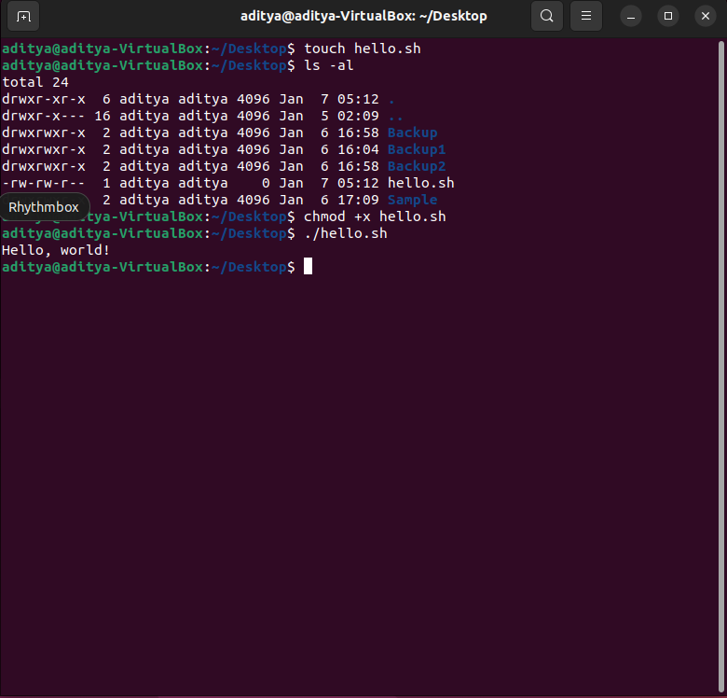

**2: Debugging Scripts**

Objective: Write a buggy shell script and use debugging to identify and fix the issue.

**Buggy script:**

#!/bin/bash

count=1

while [$count -le 5]

do

echo "Count is: $count"

((count++))

done

echo "Counting complete."

As, the above script is buggy after executing this came to know that the issue was due to a missing space after the **[** and before the **]** in the **while** loop's condition. The corrected script is:

#!/bin/bash

count=1

while [ $count -le 5 ]

do

echo "Count is: $count"

((count++))

done

echo "Counting complete."

**Output:**

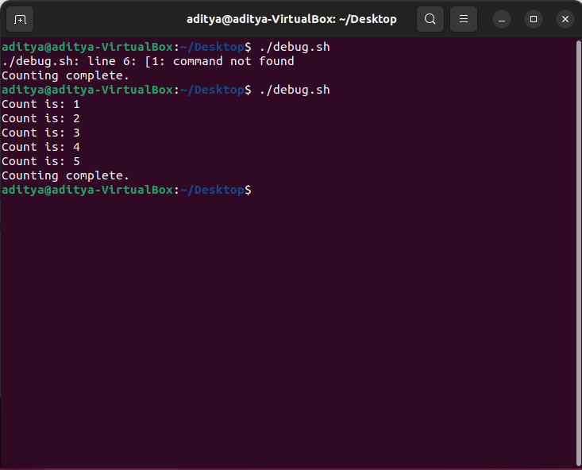

**3: Using Functions for Repetitive Tasks**

Objective: Write a shell script that uses a function to create multiple directories.

**Shell script:**

#!/bin/bash

function create_directory {

mkdir -p "$1"

echo "Directory '$1' created successfully."

}

read -p "How many directories do you want to create? " num_dirs

for (( i=1; i<=num_dirs; i++ )); do

read -p "Enter name for directory $i: " dir_name

create_directory "$dir_name"

done

echo "All directories created successfully!"

**Output:**

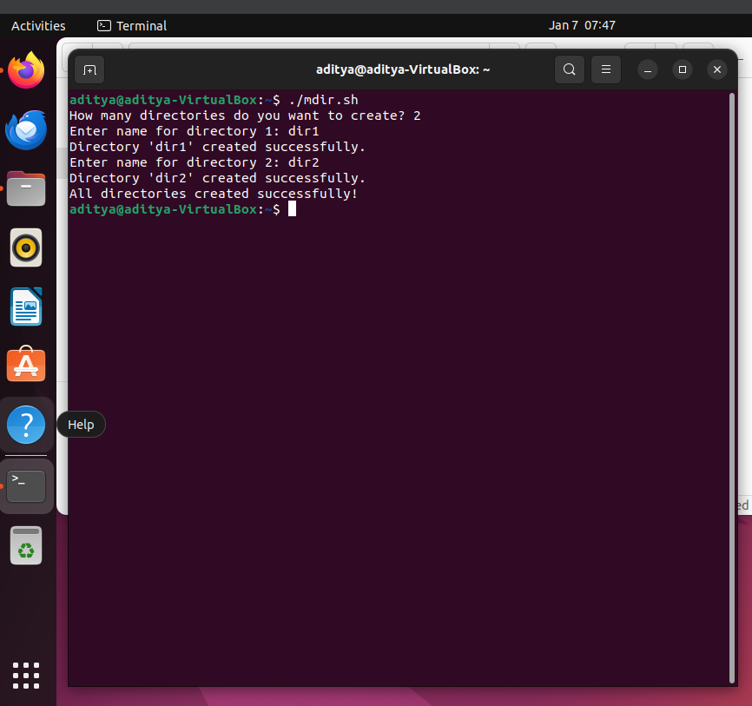

**4: Script with All Learned Concepts**

Objective: Write a shell script that uses variables, conditionals, loops, and functions to interact with the file system.

**Shell script:**

#!/bin/bash

function file_exists {

if [[ -f "$1" ]]; then

return 0 # True

else

return 1 # False

fi

}

function create_directory {

mkdir -p "$1"

}

function find_text {

grep -i "$1" "$2"

}

while true; do

read -p "Enter a filename: " filename

read -p "Enter a word to search: " search_word

if file_exists "$filename"; then

echo "File exists: $filename"

if [[ -f "$filename" ]]; then

echo "Searching for '$search_word' in $filename..."

find_text "$search_word" "$filename"

else

echo "Not a regular file."

fi

else

echo "File not found: $filename"

read -p "Create the directory? (y/n): " create_dir

if [[ $create_dir =~ ^[Yy]$ ]]; then

create_directory "$filename"

echo "Directory created."

fi

fi

read -p "Do you want to perform another run? (y/n): " perform_again

if [[ ! $perform_again =~ ^[Yy]$ ]]; then

break

fi

done

**Output:**

